
Ref: 2645/Circular/09.08

31 Aug 2008

All Residents
No.9, 11,15 Ardmore Park, Singapore

Dear Residents,

SERVICING SCHEDULES FOR THE MONTH OF SEPTEMBER 2008

Please be informed of the following servicing schedules for the lifts/fire protection system/pest control/recycling for the month of
September 2008.

S/No | Contractor | Services | Date | Time | Remarks
1 | Fire Protection Company Pte Ltd | Fire Protection | 26 September 2008 | 1300hrs to 1700hrs | Please do not be alarmed when the fire alarm is activated
2 | ABJ Pest Control Pte Ltd | Pest Control | 4, 11, 18 & 25  September 2008  (Every Thursday) | Between 0930hrs to 1200hrs | Please close (seal) your bin chute hopper and windows tightly during the fumigation
3 | SembWaste Pte Ltd | Collection of Recycle Materials | 12 & 26 September 2008  (Every 2nd and 4th Friday) | From 1000hrs to 1200hrs | Please collect recycling bags from the clubhouse.
4. | Anchor Cleaning Agency Pte Ltd | Bin Chute Flushing | 3, 6, 10, 13, 17, 20, 24, 27 & 30 September 2008  (Every Wed & Sat) | From 1000hrs to 1200hrs | Please close your bin chute hopper during the flushing

Lift Maintenance Schedule
Blk No | Lift No | Date | Time | Remarks
Block 9 | Lobby Lift No 1  Lobby Lift No 2  Lobby Lift No 3  Lobby Lift No 4  Service Lobby Lift No 10 | 16 September 2008  16 September 2008  16 September 2008  16 September 2008  16 September 2008 | 0900hrs to 1000hrs  1000hrs to 1100hrs  1100hrs to 1200hrs  1300hrs to 1400hrs  1400hrs to 1500hrs | Kindly be reminded to bring along your rear door key during this period
Block 11 | Lobby Lift No 5  Lobby Lift No 6  Lobby Lift No 7  Lobby Lift No 8  Service Lobby Lift No 11 | 17 September 2008  17 September 2008  17 September 2008  17 September 2008  17 September 2008 | 0900hrs to 1000hrs  1000hrs to 1100hrs  1100hrs to 1200hrs  1300hrs to 1400hrs  1400hrs to 1500hrs | Kindly be reminded to bring along your rear door key during this period
Block 13 | Club House P1 | 18 September 2008 | 1500hrs to 1600hrs
Block 15 | Lobby Lift No 9  Lobby Lift No 10  Lobby Lift No 11  Lobby Lift No 12  Service Lobby Lift No 12 | 18 September 2008  18 September 2008  18 September 2008  18 September 2008  18 September 2008 | 0900hrs to 1000hrs  1000hrs to 1100hrs  1100hrs to 1200hrs  1300hrs to 1400hrs  1400hrs to 1500hrs | Kindly be reminded to bring along your rear door key during this period

Weekly high-level dusting and cleaning of the private lift cars schedule:
Day of Cleaning | Time | Block /Lift Nos. | Remarks
Monday  Tuesday  Wednesday | 10.00 am to 11.00 am  11.00 am to 12.00 pm  10.00 am to 11.00 am  11.00 am to 12.00 pm  10.00 am to 11.00 am  11.00 am to 12.00 pm | Blk 9/ Lift 1 & 2  Blk 9/ Lift 3 & 4  Blk 11/ Lift 5 & 6  Blk 11/ Lift 7 & 8  Blk 15/ Lift 9 & 10  Blk 15/ Lift 11 & 12 | Please do not be alarmed if you find a cleaner in the private lift during these times.

If you have any queries, please feel free to contact us at the management office telephone number 6733 0862. We apologise for any inconvenience caused.

Yours Faithfully,

Knight Frank Estate Management Pte Ltd
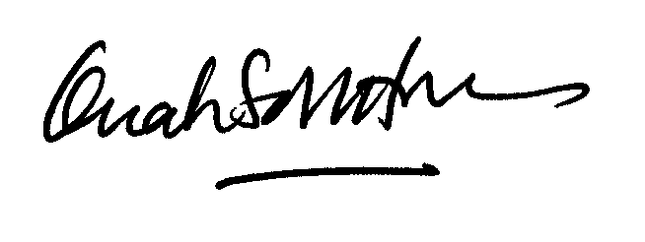

Ms Quah Soh Hoon
Ardmore Park General Manager
For and on behalf of The MCST Plan No. 2645

